- GATE questions at places where the relevant topic has been covered. MCQ or FUB or connected type questions. - 17 questions (2000-2025)
- Image conversion using Wacom.
- How do various languages apply hashing on primitive data types and also on custom objects?
- How Key-value pairs get stored in hash tables.
- How clashing is resolved by modern languages.

Need of hashing

In data structures, we can think of a data unit as a small packet that contains several fields.
Each field may store extra information or may point to another piece of data. This extra linked data is called satellite data.

For example, imagine a data packet consisting of the name of a student, his/her mobile number, his/ her roll number, a reference to another structure holding his/her academic grades and another reference holding the fields of her address.

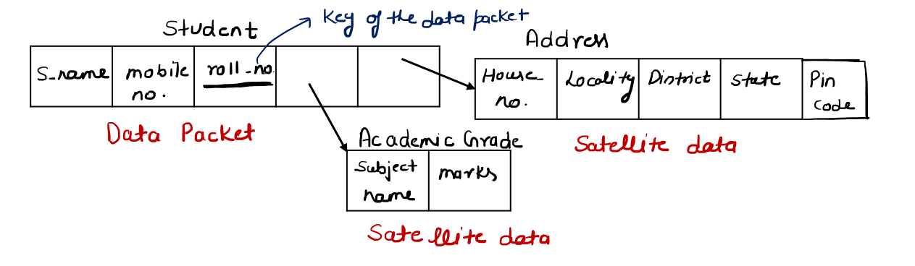
The data packet also consists of a representative key. In the above example, since the roll number is expected to be unique across all such data packets, roll number can be used as key to represent the data packet.

Searching is a very common data structure operation. Operations like modification and deletion are preceded by searching the relevant key. Most popular algorithms of searching are linear and binary. The worst and the average complexity of linear search is O(n). The worst and the average complexity of binary search is of the order of log(n). That too when the array is sorted.
Normally, searching means checking every part of the structure to find the key. But in some cases, like binary search or binary search trees, we can skip many parts of the structure. This makes the search faster and reduces the time needed.

Instead of searching everywhere to find the key, what if we could know the exact place where it is stored? Then we don’t need to search at all — we can go straight to that location in constant time. This fast and direct way of getting a key is called a lookup operation.

We can access any element of an array in constant time. This is because an array has a base address, and all its elements are stored next to each other in memory, with each element having the same size. Because of this continuous arrangement, the computer can jump directly to any element without searching. That’s why accessing an array element is always fast and in constant time.

Search in Constant Time | Using Array Indexing

Because arrays allow fast access, we can store keys in a special way. Store the given collection of keys in a large array. Put all the keys in a big array so that a key with value k is stored at index k of the array.
With this method, we don’t need to search at all — we can directly look up the key using its index.

For this to work, the array must be large enough to include the largest key value. In such a way that the key having a value of k is stored at the position having index is k. Under this approach, instead of searching for a given key we can directly look it up. The size of the underlying array should be equal to the largest key.

Take the following set of 4 keys - 1, 3, 4, 6. Since the largest key is 6, the size of the array to store the keys should be 7.

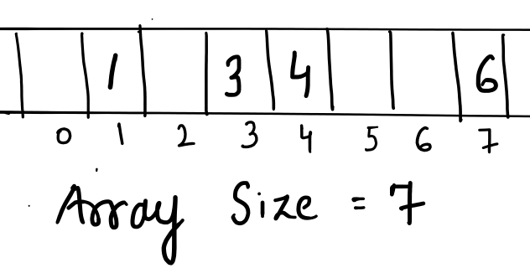

Try searching for two keys 4 and 6 and highlight that the searching in this kind of arrangement is actually looking up for the key instead of an exhaustive search of the entire structure.

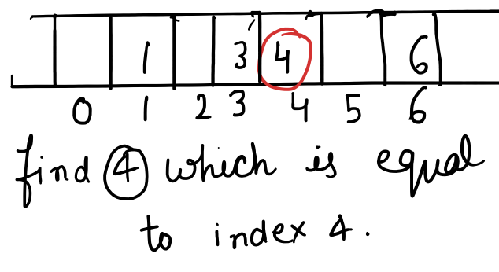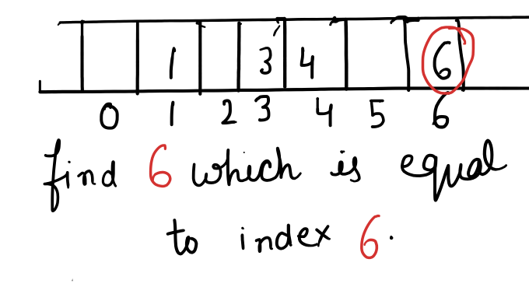

Because each key is stored at the index equal to its value, we can go directly to that index to find the key. There is no need to search through the structure. So, the time to find any key is always the same, call very fast. This is called constant time complexity (O(1)).

Problem in this Approach

The approach proposed in the previous section suffers from the following limitation.

The size of the array will be as large as the largest key in the data set. For example, for a collection of keys consisting of 3, 6, 9, 19, we have to allocate an array of size 20. Out of which only 3 will be utilized. This is inefficient usage of memory.

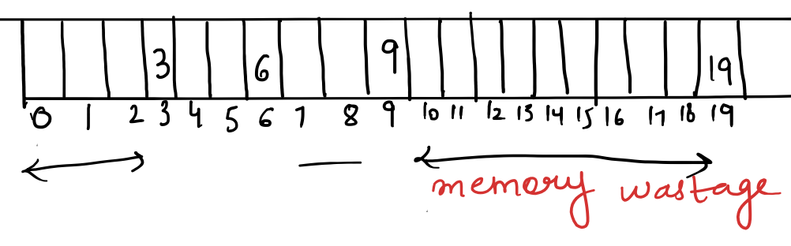

The following approach overcomes this limitation to some extent but at the cost of slighter increased time complexity. The guarantee of constant time search operation may not be honored in every case.

Search in Constant Time | Second Version

Instead of taking an array as big as the largest key we can take an array whose size equals the expected number of keys. Under this approach the size of the array will be much smaller and the array will be almost fully utilized.
But this approach has another limitation. The array will not be able to accommodate those keys, which are greater than its largest index. For example, if the expected number of keys is 4, the size of the underlying array will be 4. This array cannot accommodate keys which are greater than 3.
This problem can be resolved by transforming each key into another key of smaller magnitude (which is within the range of the allowed indexes).

Consider the following set of keys: 0, 3, 6 and 9. All these keys can be transformed into another set of keys by dividing each of them by 3. The transformed set of keys will be 0, 1, 2 and 3. Array of size 4 will be required. 0 will be saved at index = 0, 3 will be saved at index = 1 and so on.

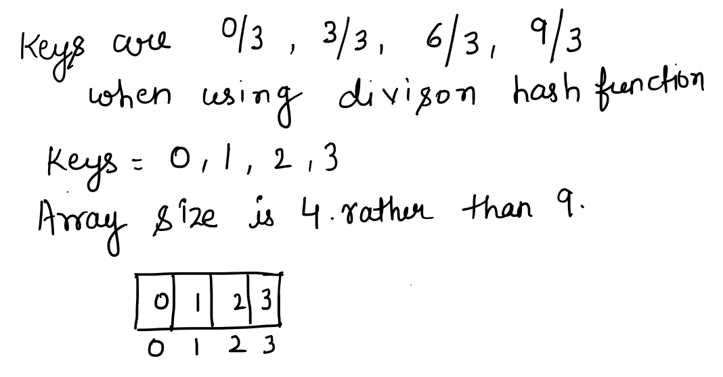

Hashing

Definition
The process of transforming a key associated with each data packet into another key, also known as hash code, is called hashing.

Hash Function
The mathematical function which transforms the key associated with each data packet into a hash code which is used to index the hash table is called a hash function.
The hash function in the above example was a division function. Every programming language has provisions for hash functions, which are usually quite complicated, instead of being a simple division function.

Hash Table
Hash Table is a data structure which stores each key at its unique index value. This unique index value is equal to the hash code obtained by applying the hash function over the key.

For example we have 4 data packets each having - student name, roll no, branch and mobile. For the sake of simplicity we are omitting the satellite data chunks and drawing just the main data packet. Choosing roll no as - 3, 6, 9 and 12 and the roll no is expected to be unique and hence we will consider roll no as the key associated with the data packets. 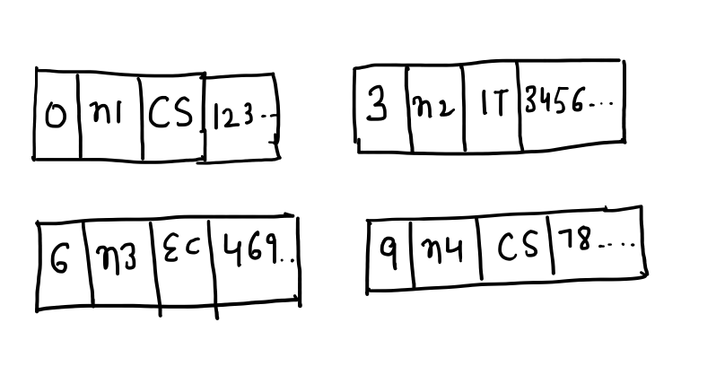
The roll number is expected to be unique and hence we will consider roll no as the key associated with the data packets. Applying the hash function (division operation).
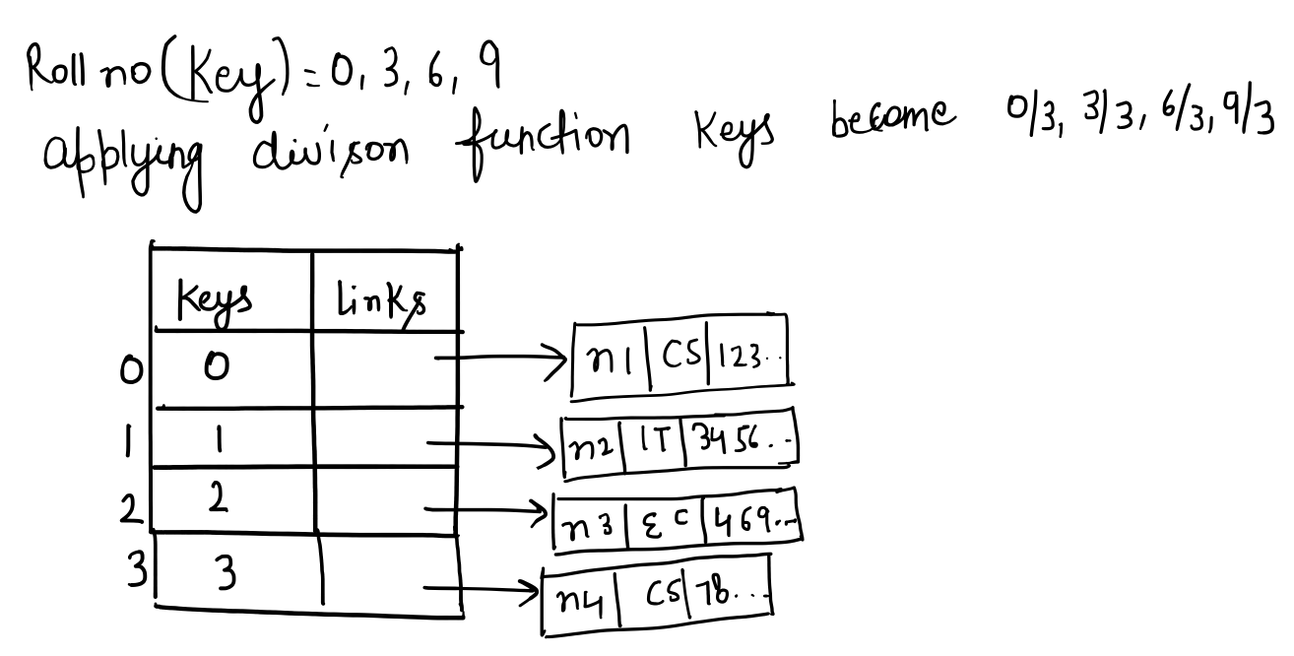

The search process in this case is constant time operation.

Hash Functions

Division Modulo Method
The size of the hash table is usually decided before the insertion of keys has even begun. The size depends upon the expected number of keys and is usually 75 percent more than the expected number of keys. Apart from the expected number of keys, the size of the hash table depends upon many factors, which are beyond the scope of this text.
Assuming that the size of the table has been given to us.

The Division Modulo hashing function is given below.

hashCode(key) = key mod hash_table_size

This hashing function generates a hash code, which is simply the result of applying modulo operation over the key. The number with which the modulo is taken is the size of the table.

Illustrate the application of the hashing function by making use of the following set of 10 keys - 25, 34, 62, 79, 53, 41, 90, 36, 97 and 99.

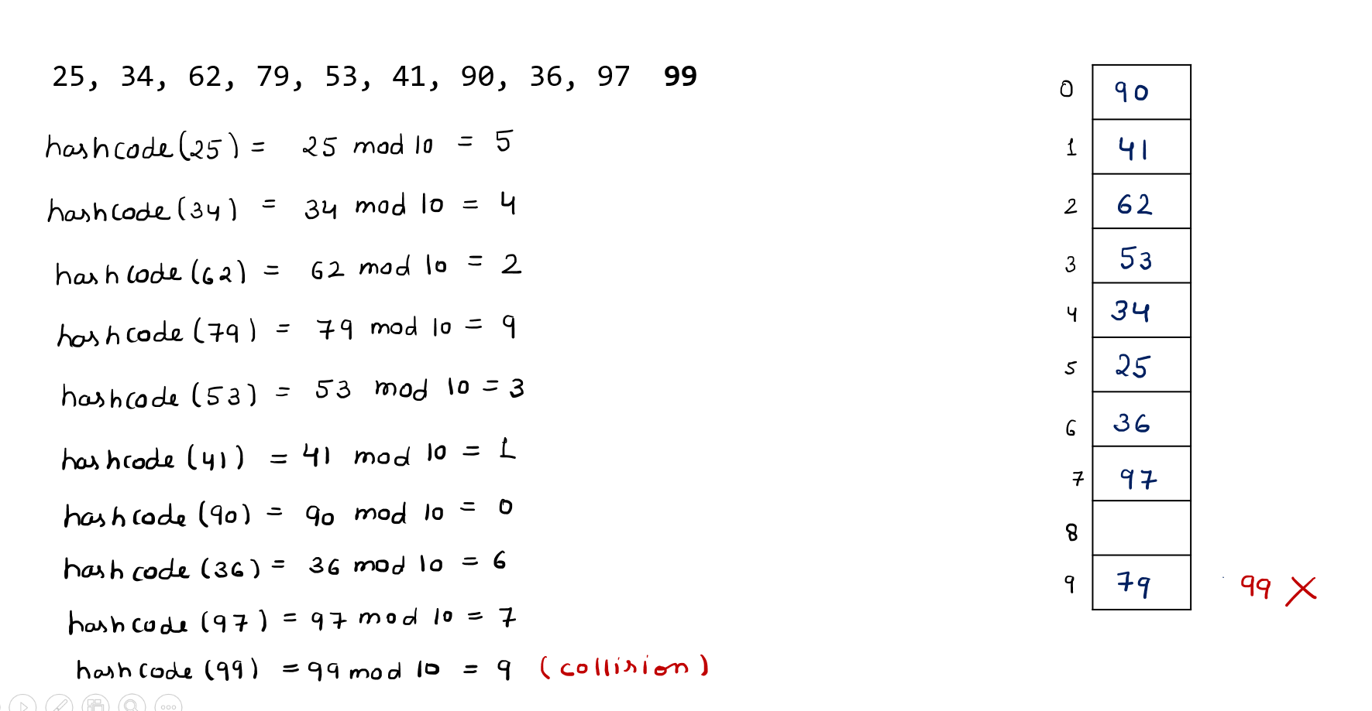

Here showing only one column of the hash table. The other column carries the references to the data packets which are being represented by the keys. This column has been omitted for clarity.

Digit Extraction
If the number of digits in the largest index (which the size of the hash table allows) is k, then the digit extraction approach creates a hash code for the given key by picking any k number of digits from the given key.

For a hash table of size 100, the value of k will be 2. And we may pick the first 2, the last 2 or any 2 digits from the given key. The choice as to which 2 digits are to be picked depends upon the programmer and is driven by the need to minimize collision. But the choice pattern should be the same during each hashing operation.

For example, 34 will be the hash code representing the key = 34678, if we are picking the first 2 digits. 78 will be the hash code representing the key if we are picking the last 2 digits.

Mid Square

If the number of digits in the largest index (which the size of the hash table allows) is k, then this hashing process suggests picking the middle k digits from the square of the given key to act as the hash code.

For example, if the given key is 34678 and k is equal to 2, then 56 will be the hash code representing the key (square of this key is 1202563684). And if the given key is 104, then the square is 10816. Now the middle can be 08 or 81. We can choose any one of them. In this case too, the choice depends upon the programmer and is driven by the need to minimize collision. But the choice pattern should be the same during each hashing operation.

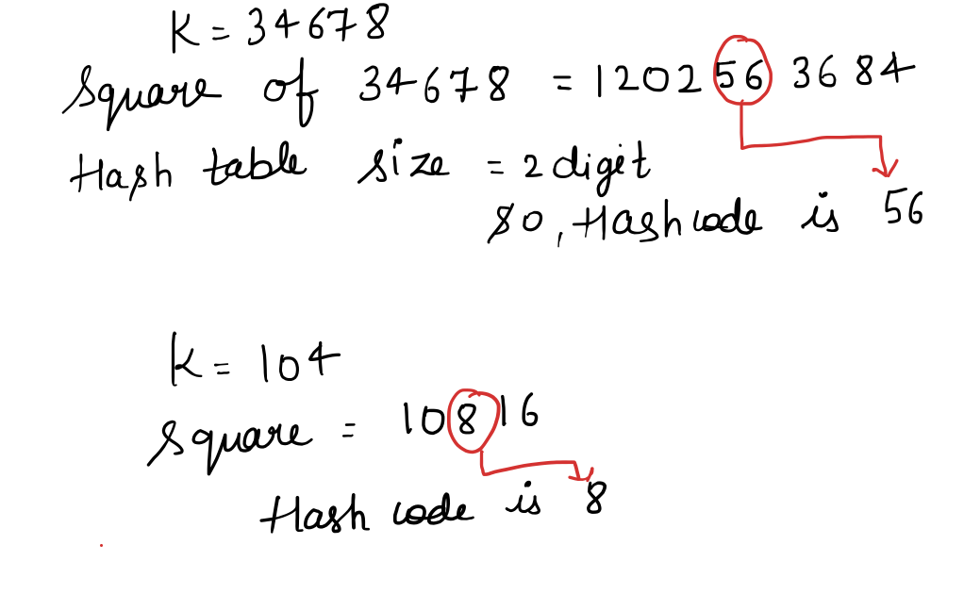

Folding
If the number of digits in the largest index (which the size of the hash table allows) is k, then this hashing process suggests breaking the key in groups of k digits (starting from the first digit) and adding the groups together.

For example if k = 3 and the key is 92345678. Breaking down into groups of 3 and adding. 923 + 456 + 78 = 1457. This is a 4 digit number. We need to reduce it further following the same process. 145 + 7 = 152. This will become the hash code representing the original key (92345678).

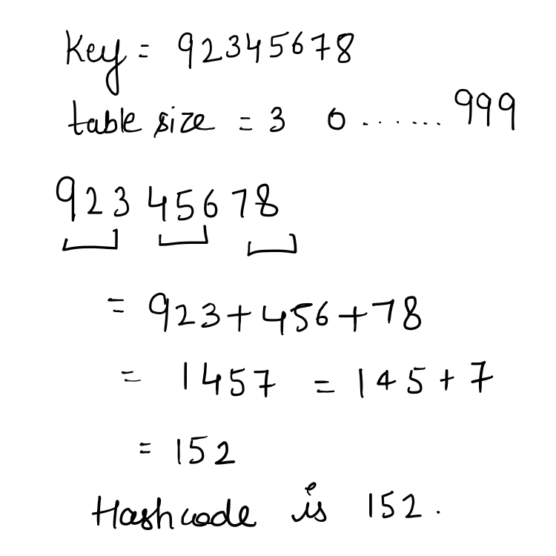

Custom Hash Function
Based upon requirements we can create our own hash functions.
Example : k/3, k mod 9

Operations Over Hash Table
Here, we will cover standard operations applied over Hash Table without any collision. When the hash size is full then memory is resized based on the load factor (number of elements / number of buckets, it indicates how full the hash table is).
All the upcoming sections will use the following table for illustrations.
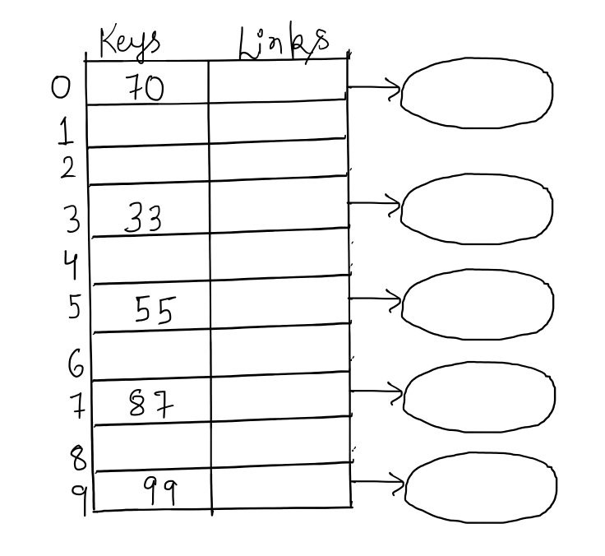

Search
Searching in a hash table is actually a look-up operation. The given key is converted into the hash code by applying the hashing function. The sought key can be looked up in the hash table at an index whose value is the hash code. This makes it an O(1) operation.

Problem Statement

Search the given key (key) in a hash table (hashTable). The hashTable can be considered to be a 2D array as described in the previous section.

Algorithm Search(key, hashTable)
- hashCode = HashFunction(key)
- If hashTable[hashCode][0] == key
- Return True
- Else
- Return False

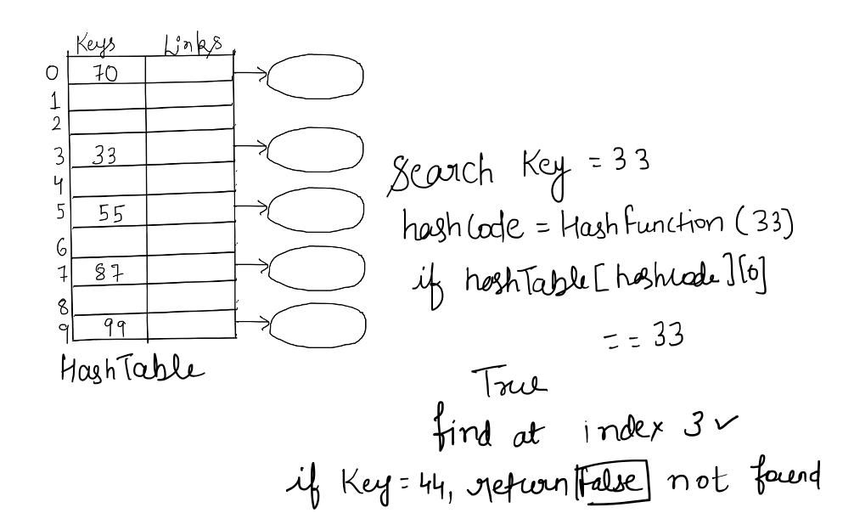

Complexity of Search

The complexity of the above algorithm is O(1). All steps are constant time operation, including step 2, which looks up the key in the Hash Table. This algo takes O(1) in every case (worst, best and average), if the keys are not colliding.

Insertion

Problem Statement

Insert the given key (key) in a hash table (hashTable). The hashTable can be considered to be a 2D array as described in the previous section. It can be assumed that the key is not colliding with any of the existing keys.

Algorithm Insertion(key, hashTable)
- hashCode = hashFunction(key)
- hashTable[hashCode][0] = key

Complexity of Insertion

The complexity of the above algorithm is O(1). All steps are constant time operation, including step 2, which stores the key in the hash table. Then finally suggest that the algo takes O(1) in every case (worst, best and average), if the keys are not colliding.

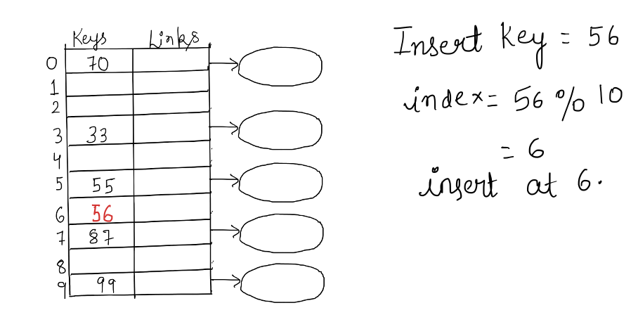

Deletion

Problem Statement

Delete the given key (key) from the given hash table (hashTable). The hashTable can be considered to be a 2D array as described in the previous section.

Algorithm Deletion(key, hashTable)
- hashCode = HashFunction(key)
- If hashTable[hashCode][0] == key
- hashTable[hashCode][0] = None
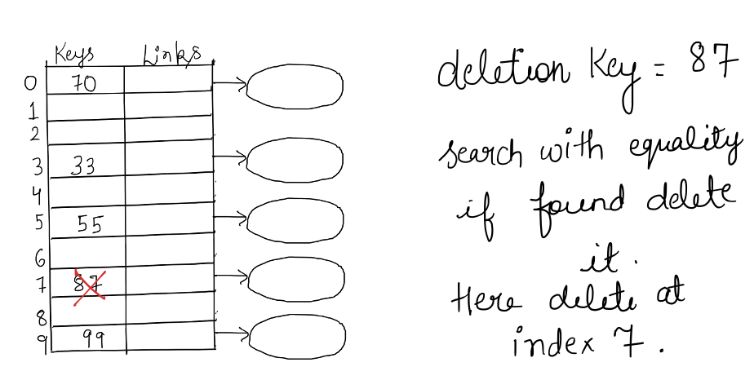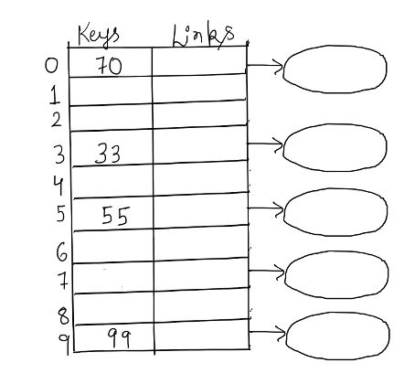

Complexity of Deletion

Complexity of the above algorithm is O(1). All steps are constant time operation, including step 3, which deletes the key from the hash table. Then finally suggest that the algo takes O(1) in every case (worst, best and average).

 | Gate 2015 Set 2
1. | Which one of the following hash functions on integers will distribute keys most uniformly over 10 buckets numbered 0 to 9 for iii ranging from 0 to 2020?
A | h(i) = i^2 mod 10
B | h(i) = i^3 mod 10
C | h(i) =(11∗i^2) mod10
D | h(i) =(12∗i) mod10
AN | B

 | Gate 2015 Set 2
2. | Given a hash table T with 25 slots that stores 2000 elements, the load factor alpha α for T is __________.
AN | 80

Collision

Illustration of Collision

Earlier, the size of the hash table had to match the largest key. To reduce this size, we convert big keys into smaller numbers using a hash function. These smaller numbers are called hash codes. But when we shrink a large range of keys into a much smaller range, different keys can get the same hash code. This situation is called a collision, and it is expected to happen.

An example of a 10 sized hash table. And the following keys of 25, 34, 62, 79, 53, 41, 90, 36, 97, 99, 75. Applying division modulo hash function. The range of the transformed keys will always be 0 to 9. Which are 10 units. Whereas the range of the original keys is 25 to 99.

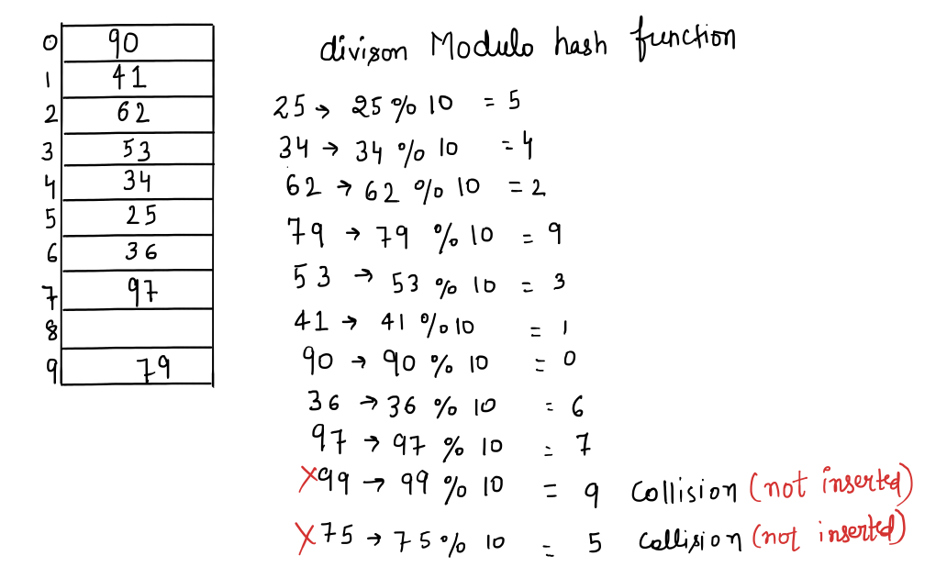

Converted keys into hash code. 5, 4, 2, 9, 3, 1, 0, 6, 7, 9, 5. We are getting the same value of the hash code, which is 9 and 5, for two different values of keys, which are 79 , 99 and 25 , 75.

Collision Resolution Techniques

Open Hashing or Separate Chaining
In the earlier hash table diagram, the table had two vertical columns. The first column stored keys at positions that matched their hash code. The second column stored a link or reference to the actual data packet that belonged to that key. So each hash code pointed to the data connected with that key.

Now, we don’t need a 2D array anymore. A single 1D array is enough. At each index of the array (which represents a hash code), we store a pointer to the head of a linked list.
This linked list will keep the references to all data packets whose keys produce the same hash code. So, if a collision happens (two keys get the same hash code), we simply add the new data packet’s reference to the linked list at that index. This way, all colliding keys are stored together in a list at the same array position.

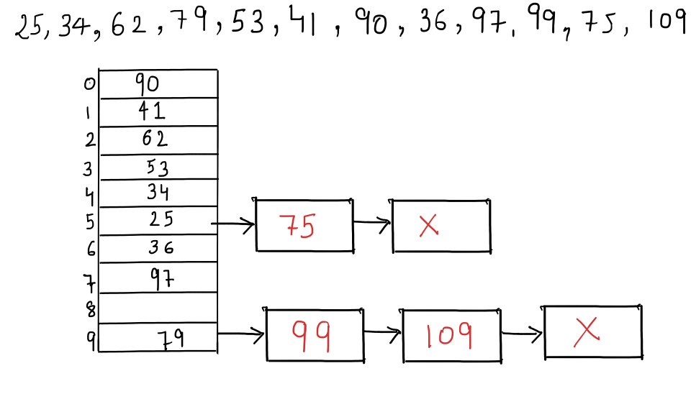
The advantage of this method is that it can handle any number of collisions, because we can keep adding items to the linked list. But the downside is that search becomes slower.
If many items land in the same linked list, we must search through that list to find the correct
one. Next, we will see how this affects the search time.

 | Gate 2014
3. | Consider a hash table with 100 slots. Collisions are resolved using chaining. Assuming simple uniform hashing, what is the probability that the first 3 slots are unfilled after the first 3 insertions?
A | (97 × 97 × 97) / 100^3
B | (97 × 98 × 97)/100^3
C | (97 × 96 × 95)/100^3
D | (97 × 96 × 95)/(3! × 100^3 )
AN | A

 | Gate 2014
4. | Consider the hash table with 9 slots. The hash function is h(K) = k mod 9. The collision are resolved by chaining. The following 9 keys are inserted in the order: 5, 28, 19, 15, 20, 33, 12, 17, 10. The maximum, minimum, and average chain lengths in the hash table, respectively are
A | 3, 0 and 1
B | 3, 3 and 3
C | 4, 0 and 1
D | 3, 0 and 2
AN | A

Closed Hashing | Open Addressing
First, apply the hash function to get the hash code. Place the key in the hash table at the index equal to this hash code. If the slot is already occupied (in case of collision) then either go for chaining, which we covered in the previous section, or look for the next available slot to insert the key. To decide which slot to check next, there are three common methods, which we will learn next.

Linear Probing

It will check the next slot:

index = (hash_code + i) mod hash_table_size

Where i is the number of collisions already encountered for the given key. It will range from 0 to hash_table_size - 1.

When you are trying to insert the key for the first time, put i = 0 to get the index of the slot. In case of collision put i = 1 (first collision happened) to get the index of the next slot. Repeat this process till i = hash_table_size - 1. No use of going further because putting i = hash_table_size will give you the index which you tried for the very first time. By this time you would have already covered all the possible alternate slots which this type of probing can give. At this point it can be concluded that the present collision cannot be resolved by this type of probing.

Example : a Hash table of size = 10 and 9 keys. Use division modulo as the hash function.

Use the following set of keys - 25, 54, 79, 43, 65, 28, 93, 64, 18

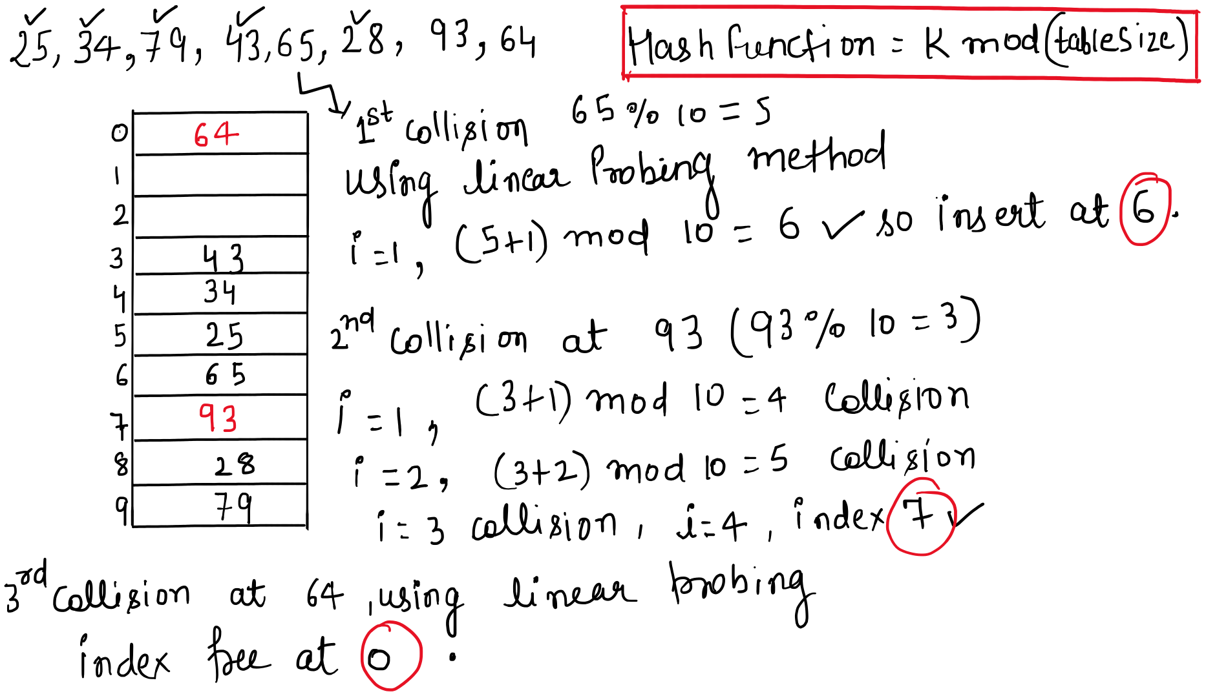

 | Gate 2025 CS1
5. | In a double hashing scheme, ℎ1 (𝑘) = 𝑘 mod 11 and ℎ2(𝑘) = 1 + (𝑘 mod 7) are  the auxiliary hash functions. The size 𝑚 of the hash table is 11. The hash function for the i-th probe in the open address table is [ℎ1(𝑘) + 𝑖 ℎ2(𝑘)] mod 𝑚.  The following keys are inserted in the given order: 63, 50, 25, 79, 67, 24.  The slot at which key 24 gets stored is ___________. (Answer in integer)
AN | 10

 | Gate 2005
6. | A hash table contains 10 buckets and uses linear probing to resolve collisions. The key values are integers and the hash function used is key%10. If the values 43,165,62,123,142 are inserted in the table, in what location would the key value 142 be inserted?
A | 2
B | 3
C | 4
D | 6
AN | D

 | Gate 2004
7. | Given the following input (4322, 1334, 1471, 9679, 1989, 6171, 6173, 4199) and the hash function x mod 10, which of the following statements are true?  I. 9679, 1989, 4199 hash to the same value  II. 1471, 6171 hash to the same value  III. All elements hash to the same value  IV. Each element hashes to a diﬀerent value
A | I only
B | II only
C | I and II only
D | III or IV
AN | C

 | Gate 2007
8. | Consider a hash table of size seven, with starting index zero, and a hash function (3x + 4) mod 7. Assuming the hash table is initially empty, which of the following is the contents of the table when the sequence 1, 3, 8, 10 is inserted into the table using closed hashing? Note that ’-’ denotes an empty location in the table.
A | 8,-,-,-,-,-10
B | 1, 8, 10,-,-,-,3
C | 1,-,-,-,-,-,3
D | 1, 10, 8,-,-,-,3
Ans | B

 | Gate 2016 Set 1
9. | Consider a hash table of size 7 with hash function h(k)=k mod 7 that uses linear probing for collision resolution. The keys are inserted in the following order:  50, 700, 76, 85, 92, 73, 101  What is the index of the key 73 after all insertions are complete?
AN | 4

 | Gate 2008
10. | Consider a hash table of size 11 that uses open addressing with linear probing. Let h(k) = k mod 11 be the hash function used. A sequence of records with keys: 43 36 92 87 114 71 13 14 is inserted into an initially empty hash table, the bins of which are indexed from zero to ten.  What is the index of the bin into which the last record is inserted?
A | 3
B | 4
C | 6
D | 7
AN | D

 | Gate 2009
11. | The keys 12, 18, 13, 2, 3, 23, 5 and 15 are inserted into an initially empty hash table of length 10 using open addressing with hash function h(k) = k mod 10 and linear probing . What is the resultant hash table?
A
  0
  1
  2 | 2
  3 | 23
  4
  5 | 15
  6
  7
  8 | 18
  9
B
  0
  1
  2 | 12
  3 | 13
  4
  5 | 5
  6
  7
  8 | 18
  9
C
  0
  1
  2 | 12
  3 | 13
  4 | 2
  5 | 3
  6 | 23
  7 | 5
  8 | 18
  9 | 15
D
  0
  1
  2 | 12, 2
  3 | 13, 3, 23
  4
  5 | 5, 15
  6
  7
  8 | 18
  9
Ans | C

 | Gate 2010
12. | A hash table of length 10 uses open addressing with hash function h(k) = k mod 10, linear probing. After inserting 6 values into an empty hash table , the table is a shown below.
  0
  1
  2 | 42
  3 | 23
  4 | 34
  5 | 52
  6 | 46
  7 | 33
  8
  9
Q1 | Which one of the following choices gives a possible order in which the key values have been inserted in the table?  (a) 46, 42, 34, 52, 23, 33  (b) 34, 42, 23, 52, 33, 46  (c) 46, 34, 42, 23, 52, 33  (d) 42, 46, 33, 23, 34, 52 4.
AN | Key value 42, 23, 34, 46 are on their slots so their ordering does not matters.  key value 52 is on slot no. 6, it means there were three collision so 52 will always be after 42, 23, 34, in the sequence. 33 is slotted on slot No. 7 but it should be on slot No. 3, it means there are 4 collisions so 33 will be at Last in sequence. 4.
Q2 | How many different insertion sequences of the key values using the same hash function and linear probing will result in the hash table shown above?  (a) 10 (b) 20 (c) 30 (d) 40
AN | C

Quadratic Probing

It will jump in increasing square steps:

index = (hash_code + i + i^2) mod hash_table_size

Where i is the number of collisions already encountered for the given key. It will range from 0 to hash_table_size - 1.

When you are trying to insert the key for the first time, put i = 0 to get the index of the slot. In case of collision put i = 1 (first collision happened) to get the index of the next slot. Repeat this process till i = hash_table_size - 1. No use of going further because putting i = hash_table_size will give you the index which you tried for the very first time. By this time you would have already covered all the possible alternate slots which this type of probing can give. At this point it can be concluded that the present collision cannot be resolved by this type of probing.

Example : a Hash table of size = 10 and 9 keys. Use division modulo as the hash function.

Use the following set of data - 25, 54, 79, 43, 65, 28, 64, 18, 93.

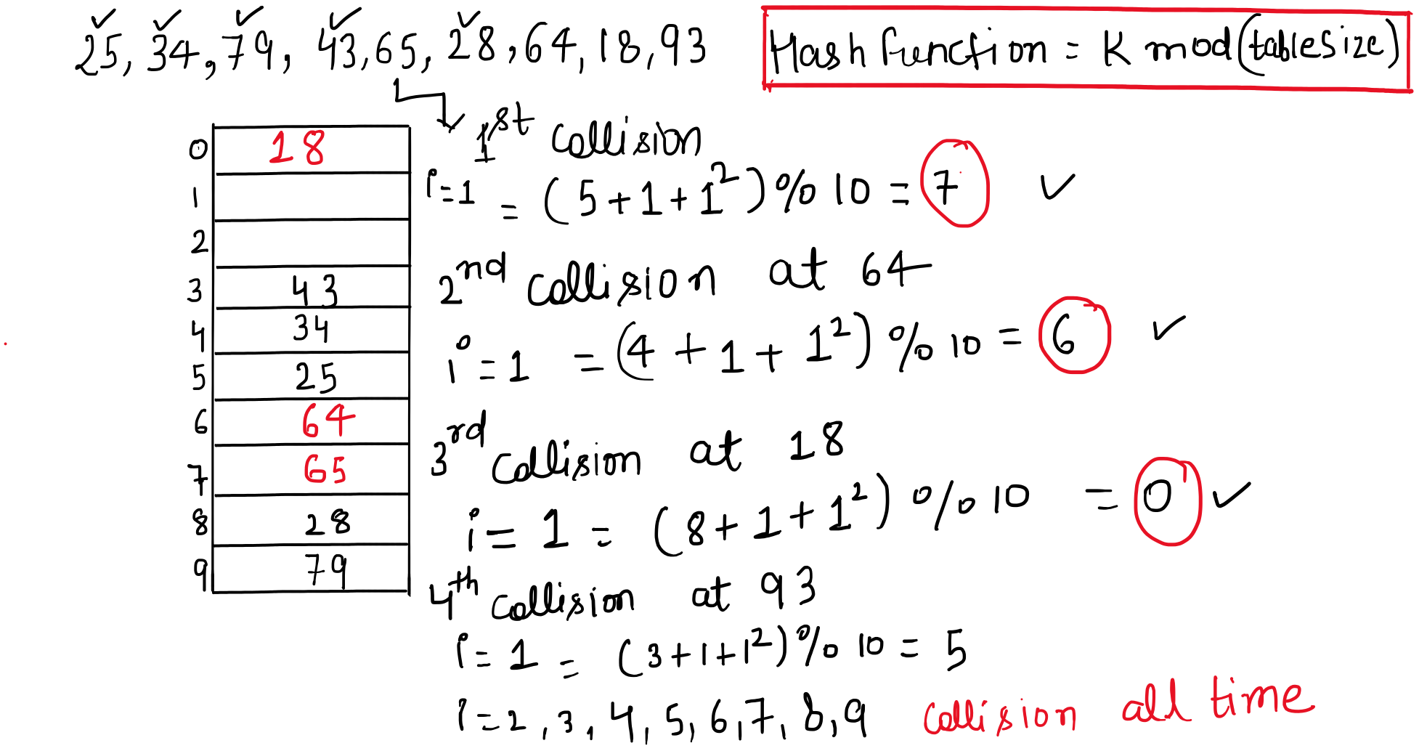
Using the said approach, you will not be able to place 93 in the hash table, in spite of empty slots available. This is the shortcoming of the Quadratic Probing approach.

Double Hashing
It will use a second hash function:

index = (hash_code + i * HashFunTwo(key)) mod hash_table_size

Where i is the number of collisions already encountered for the given key. It will range from 0 to hash_table_size - 1. And HashFunTwo can be any valid hash function.

When you are trying to insert the key for the first time, put i = 0 to get the index of the slot. In case of collision put i = 1 (first collision happened) to get the index of the next slot. Repeat this process till i = hash_table_size - 1. No use of going further because putting i = hash_table_size will give you the index which you tried for the very first time. By this time you would have already covered all the possible alternate slots which this type of probing can give. At this point it can be concluded that the present collision cannot be resolved by this type of probing.

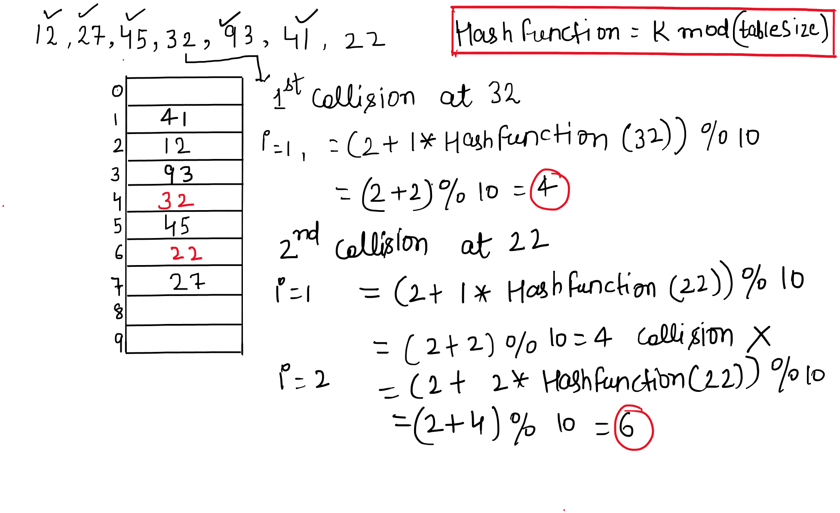

Example : take a Hash table of size = 10 and 8 keys. Use division modulo as the main hash function and any other suitable hash function for HashFunTwo.

 | Gate 2020
13. | Consider a double hashing scheme in which the primary hash function is Q.18 h1(k) = k mod 23  and the secondary hash function is h2(k) = 1 + (k mod 19). Assume that the table size is 23. Then the address returned by probe 1 in the probe sequence (assume that the probe sequence begins at probe 0) for key value k = 90 is ________.
AN | 13

 | Gate 2023
14. | An algorithm has to store several keys generated by an adversary in a hash  table. The adversary is malicious who tries to maximize the number of collisions.  Let k be the number of keys, m be the number of slots in the hash table, and k>m.  Which one of the following is the best hashing strategy to counteract the adversary?
A | Division method, i.e., use the hash function h(k) = k mod m.
B | Multiplication method, i.e., use the hash function h(k) = m(kA − kA), where A is a carefully chosen constant.
C | Universal hashing method.
D | If k is a prime number, use Division method. Otherwise, use Multiplication method.
AN | C

 | Gate 2022
15. | Suppose we are given n keys, m hash table slots, and two simple uniform hash functions h1 and h2. Further suppose our hashing scheme uses h1 for the odd keys and h2 for the even keys. What is the expected number of keys in a slot?
A | m / n
B | n / m
C | 2n / m
D | n / 2m
AN | B

 | Gate 2007
16. | Consider a hash function that distributes keys uniformly. The hash table size is 20. After hashing of how many keys will the probability that any new key hashed collides with an existing one exceed 0.5.
A | 5
B | 7
C | 7
D | 10
AN | D

 | Gate 2006
17. | Which of the following statement(s) is TRUE?  (I) A hash function takes a message of arbitrary length and generates a fixed length code.  (II) A hash function takes a message of fixed length and generates a code of variable length.  A hash function may give the same hash value for distinct messages.
A | I only
B | II and III only
C | I and III only
D | II only
AN | C

Programming based hashing technique
- Process to Obtain Hash Value of integers, char, short.
- Process to obtain hash value of float, long and double.
- Process to obtain hash value of arbitrary objects. The class should implement hashCode, and equals. The Java runtime will call these functions to obtain the hash value of arbitrary objects.

Java
In Java, HashMap is implemented using an array of buckets, where each bucket represents a bin in the table. If multiple keys map to the same bucket index, they are stored in the same bucket. Collision handling is done using separate chaining.

The default load factor of HashMap is 0.75. When the number of stored entries exceeds: capacity × load factor, the HashMap is resized, and rehashing is performed to redistribute entries across a larger bucket array.

Java computes a hash value for the key using the key’s hashCode() method and then applies an additional hash spreading step to improve bit distribution.

hash = key.hashCode();
hash = hash ^ (hash >>> 16);
bucketIndex = (capacity - 1) & hash;

Starting from Java 8, if the number of entries in a single bucket exceeds a certain threshold, the linked list is converted into a balanced Red-Black Tree.
This optimization reduces the worst-case lookup time from O(n) to O(log n) for heavily collided buckets.

How Java implements and manages Hash Table

- Hash Table is an array.
- It uses a process/formula to obtain an integer which represents an index of the above array. The reference to the object is saved at this location.
- If the capacity of the underlying array is exhausted, it creates another array with double the size and proceeds from scratch.

How does Java Resolves Collision
- If two different objects give the same hash value, both are stored in the same bucket as the linked list.
- If the size of the linked list exceeds some value Java converts it into RB Tree.

import java.util.*;
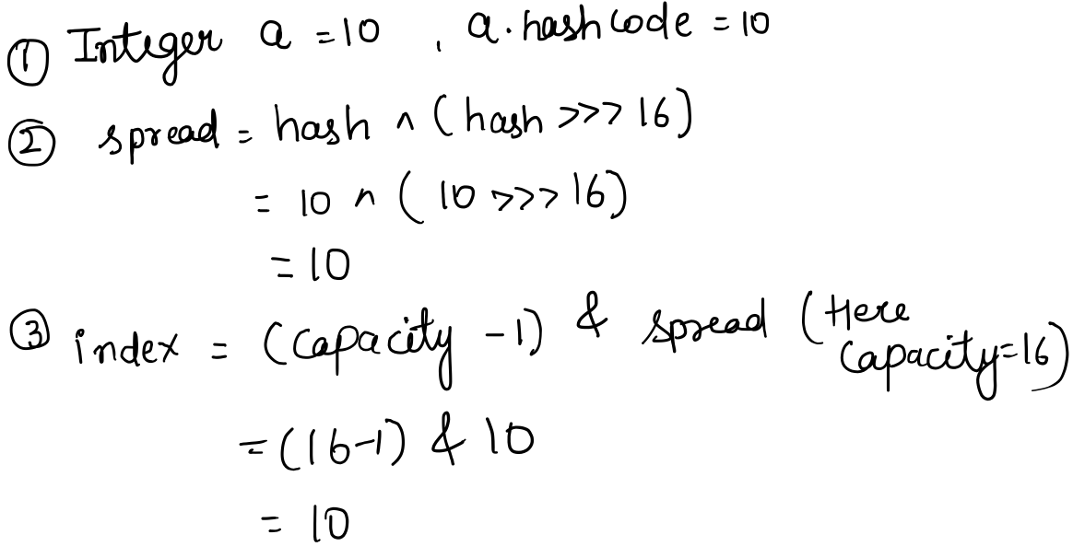
class Main {
int a,b;
String s = " this is string";
public static void main (String[] args) {
Main obj = new Main();
obj.a = 10;
obj.b = 10;
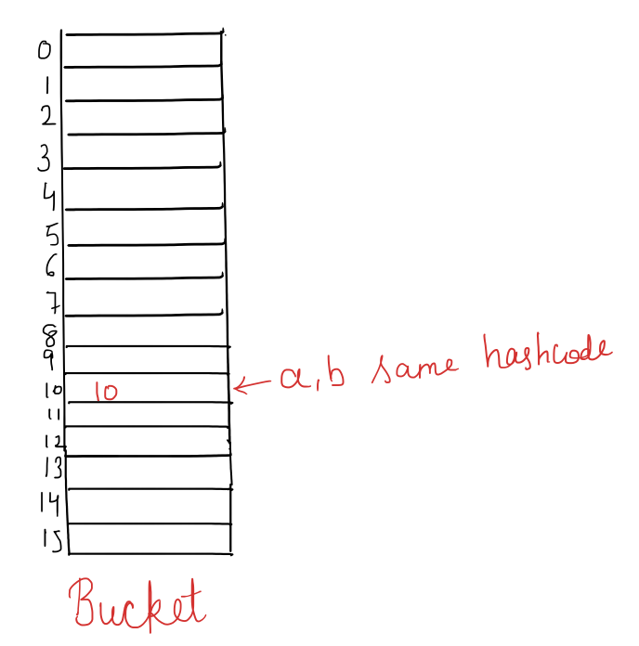
int h = 0;
for(int i = 0; i<obj.s.length();i++)
h = 31 * h + obj.s.charAt(i);
Integer aobj = obj.a;
Integer bobj = obj.b;
System.out.println(h);
System.out.println(aobj.hashCode());
System.out.println(bobj.hashCode());
System.out.println(obj.s.hashCode());
}
}

Output :
-289143579
10
10
-289143579
—--------------------------------------
import java.util.HashMap;
class Main {
public static void main(String[] args) {
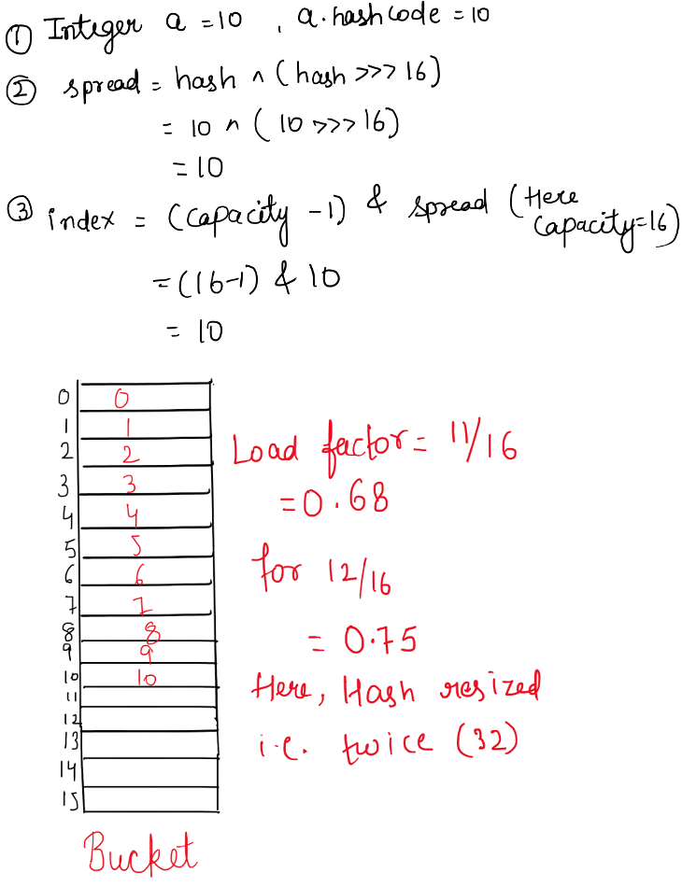
HashMap<Integer, Integer> mp = new HashMap<>();
System.out.println("Initial size: " + mp.size());
System.out.println("Default load factor: 0.75");
System.out.println("Initial capacity: 16");

for (int i = 0; i < 20; i++) {
mp.put(i, i);
System.out.println(
"Key: " + i +
", Value: " + mp.get(i) +
", Size: " + mp.size() +
", Capacity: " + capacity(mp) +
", Threshold: " + threshold(mp)
);
}
}

static int capacity(HashMap<?, ?> map) {
return map.size() == 0 ? 16 :
Integer.highestOneBit((int)(map.size() / 0.75f)) << 1;
}

static int threshold(HashMap<?, ?> map) {
return (int)(capacity(map) * 0.75f);
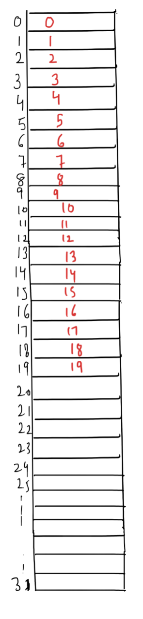
}
}

Output :
Initial size: 0
Default load factor: 0.75
Initial capacity: 16
Key: 0, Value: 0, Size: 1, Capacity: 2, Threshold: 1
Key: 1, Value: 1, Size: 2, Capacity: 4, Threshold: 3
Key: 2, Value: 2, Size: 3, Capacity: 8, Threshold: 6
Key: 3, Value: 3, Size: 4, Capacity: 8, Threshold: 6
Key: 4, Value: 4, Size: 5, Capacity: 8, Threshold: 6
Key: 5, Value: 5, Size: 6, Capacity: 16, Threshold: 12
Key: 6, Value: 6, Size: 7, Capacity: 16, Threshold: 12
Key: 7, Value: 7, Size: 8, Capacity: 16, Threshold: 12
Key: 8, Value: 8, Size: 9, Capacity: 16, Threshold: 12
Key: 9, Value: 9, Size: 10, Capacity: 16, Threshold: 12
Key: 10, Value: 10, Size: 11, Capacity: 16, Threshold: 12
Key: 11, Value: 11, Size: 12, Capacity: 32, Threshold: 24
Key: 12, Value: 12, Size: 13, Capacity: 32, Threshold: 24
Key: 13, Value: 13, Size: 14, Capacity: 32, Threshold: 24
Key: 14, Value: 14, Size: 15, Capacity: 32, Threshold: 24
Key: 15, Value: 15, Size: 16, Capacity: 32, Threshold: 24
Key: 16, Value: 16, Size: 17, Capacity: 32, Threshold: 24
Key: 17, Value: 17, Size: 18, Capacity: 32, Threshold: 24
Key: 18, Value: 18, Size: 19, Capacity: 32, Threshold: 24
Key: 19, Value: 19, Size: 20, Capacity: 32, Threshold: 24

—--------------------------------------

import java.util.HashMap;
class MyObject {
int number;
String text;
MyObject(int number, String text) {
this.number = number;
this.text = text;
}
@Override
public String toString() {
return "(" + number + ", " + text + ")";
}
}

class Main {
public static void main(String[] args) {
HashMap<Integer, MyObject> mp = new HashMap<>();
System.out.println("Initial size: " + mp.size());
System.out.println("Default load factor: 0.75");
System.out.println("Initial capacity: 16");
for (int i = 0; i < 20; i++)
mp.put(i, new MyObject(i, "String" + i));
for (int i = 0; i < 20; i++)
System.out.println("Key: " + i +
", Value: " + mp.get(i) +
", Size: " + mp.size() +
", Capacity: " + capacity(mp) +
", Threshold: " + threshold(mp));
}
static int capacity(HashMap<?, ?> map) {
return map.size() == 0 ? 16 : Integer.highestOneBit((int)(map.size() / 0.75f)) << 1;
}
static int threshold(HashMap<?, ?> map) {
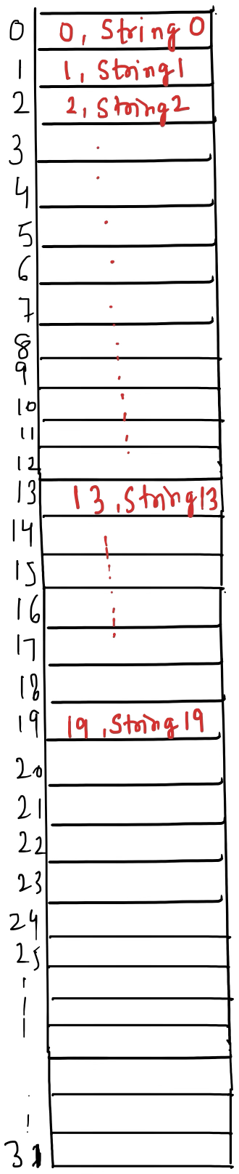
return (int)(capacity(map) * 0.75f);
}
}

Initial size: 0
Default load factor: 0.75
Initial capacity: 16
Key: 0, Value: (0, String0), Size: 20, Capacity: 32, Threshold: 24
Key: 1, Value: (1, String1), Size: 20, Capacity: 32, Threshold: 24
Key: 2, Value: (2, String2), Size: 20, Capacity: 32, Threshold: 24
Key: 3, Value: (3, String3), Size: 20, Capacity: 32, Threshold: 24
Key: 4, Value: (4, String4), Size: 20, Capacity: 32, Threshold: 24
Key: 5, Value: (5, String5), Size: 20, Capacity: 32, Threshold: 24
Key: 6, Value: (6, String6), Size: 20, Capacity: 32, Threshold: 24
Key: 7, Value: (7, String7), Size: 20, Capacity: 32, Threshold: 24
Key: 8, Value: (8, String8), Size: 20, Capacity: 32, Threshold: 24
Key: 9, Value: (9, String9), Size: 20, Capacity: 32, Threshold: 24
Key: 10, Value: (10, String10), Size: 20, Capacity: 32, Threshold: 24
Key: 11, Value: (11, String11), Size: 20, Capacity: 32, Threshold: 24
Key: 12, Value: (12, String12), Size: 20, Capacity: 32, Threshold: 24
Key: 13, Value: (13, String13), Size: 20, Capacity: 32, Threshold: 24
Key: 14, Value: (14, String14), Size: 20, Capacity: 32, Threshold: 24
Key: 15, Value: (15, String15), Size: 20, Capacity: 32, Threshold: 24
Key: 16, Value: (16, String16), Size: 20, Capacity: 32, Threshold: 24
Key: 17, Value: (17, String17), Size: 20, Capacity: 32, Threshold: 24
Key: 18, Value: (18, String18), Size: 20, Capacity: 32, Threshold: 24
Key: 19, Value: (19, String19), Size: 20, Capacity: 32, Threshold: 24

https://docs.oracle.com/en/java/javase/24/docs/api/java.base/java/util/HashMap.html https://docs.oracle.com/javase/8/docs/api/java/lang/String.html#hashCode()

Cpp

In GNU C++ (libstdc++), hashing is implemented using open hashing (separate chaining).
Elements are organized into buckets, and all elements that produce the same bucket index are stored together in the same bucket.

Collisions in unordered_map and unordered_set are resolved by storing multiple elements in a single bucket, typically using linked lists.

The hash function (std::hash) is responsible only for generating the hash value.
Mapping the hash value to a bucket index and resolving collisions are handled by the hash table mechanism using separate chaining.

C++ maintains the load factor (default ≈ 1.0) and resizes (rehashes) the table when this limit is exceeded. Rehashing occurs when: size() > bucket_count() × max_load_factor()

During rehashing, the container allocates a new bucket array, and in GNU STL, the new bucket count is typically chosen as the next suitable prime number to improve hash distribution.

C++ allows programmers to explicitly control the load factor and bucket count using max_load_factor() and rehash().

The bucket index is computed as: bucket_index = hash_value % bucket_count

How CPP implements and manages Hash Table

- Just like Java, it is an array-based hash table.
- C++ uses std::hash<Key> to generate an integer hash value.
- Hash value is converted to an index using:
index = hash(key) % bucket_count
The modulo operation is used because bucket count is not necessarily a power of two.

How does CPP Resolves Collision

- If two different objects give the same hash value, both are stored in the same bucket as the linked list.

#include <iostream>
#include <unordered_map>
using namespace std;
int main() {
unordered_map<int, int> mp;
cout << "Initial buckets: " << mp.bucket_count() << endl;
cout << "Max load factor: " << mp.max_load_factor() << endl;
// mp.max_load_factor(0.5); changing default load factor of hash memory
for (int i = 0; i < 20; i++) {
mp[i] = i;
cout << "Size: " << mp.size()
<< ", Buckets: " << mp.bucket_count()
<< ", Load factor: " << mp.load_factor()
<< endl;
}
}
Output :
Initial buckets: 1
Max load factor: 1
Size: 1, Buckets: 13, Load factor: 0.0769231
Size: 2, Buckets: 13, Load factor: 0.153846
Size: 3, Buckets: 13, Load factor: 0.230769
Size: 4, Buckets: 13, Load factor: 0.307692
Size: 5, Buckets: 13, Load factor: 0.384615
Size: 6, Buckets: 13, Load factor: 0.461538
Size: 7, Buckets: 13, Load factor: 0.538462
Size: 8, Buckets: 13, Load factor: 0.615385
Size: 9, Buckets: 13, Load factor: 0.692308
Size: 10, Buckets: 13, Load factor: 0.769231
Size: 11, Buckets: 13, Load factor: 0.846154
Size: 12, Buckets: 13, Load factor: 0.923077
Size: 13, Buckets: 13, Load factor: 1
Size: 14, Buckets: 29, Load factor: 0.482759
Size: 15, Buckets: 29, Load factor: 0.517241
Size: 16, Buckets: 29, Load factor: 0.551724
Size: 17, Buckets: 29, Load factor: 0.586207
Size: 18, Buckets: 29, Load factor: 0.62069
Size: 19, Buckets: 29, Load factor: 0.655172
Size: 20, Buckets: 29, Load factor: 0.689655

https://gcc.gnu.org/onlinedocs/libstdc++/manual/unordered_associative.html https://gcc.gnu.org/onlinedocs/gcc-6.3.0/libstdc%2B%2B/api/a01703_source.html https://cplusplus.com/reference/unordered_map/unordered_map/load_factor/

Python

Python dictionary uses closed hashing (open addressing), where all key–value pairs are stored directly within the hash table array itself.
Python maintains the load factor at approximately 0.66; once this threshold is exceeded, the table is resized and all entries are rehashed.
Python does not use linked lists, trees, or external buckets for collision handling.
When a collision occurs, Python searches for another empty slot within the same table using a probing strategy. This design provides fast average-case lookup and insertion while remaining memory-efficient.

How Python implements and manages Hash Table

- Just like Java, it is an array-based hash table.
- Python uses hash(key) to generate an integer hash value.
- Hash value is converted to an index using:
index = hash(key) & (capacity - 1)

How does Python Resolves Collision

- If the calculated slot is already occupied, applies perturbation-based probing to locate the next available slot

class SimpleHashTable:
def __init__(self, size):
self.size = size
self.mask = size - 1
self.table = [None] * size
def insert(self, key):
h = hash(key)
index = h & self.mask
self.table[index] = key
print(f"Key={key}, Hash={h}, Index={index}")
h = SimpleHashTable(8)
for i in range(1, 11):
h.insert(i)

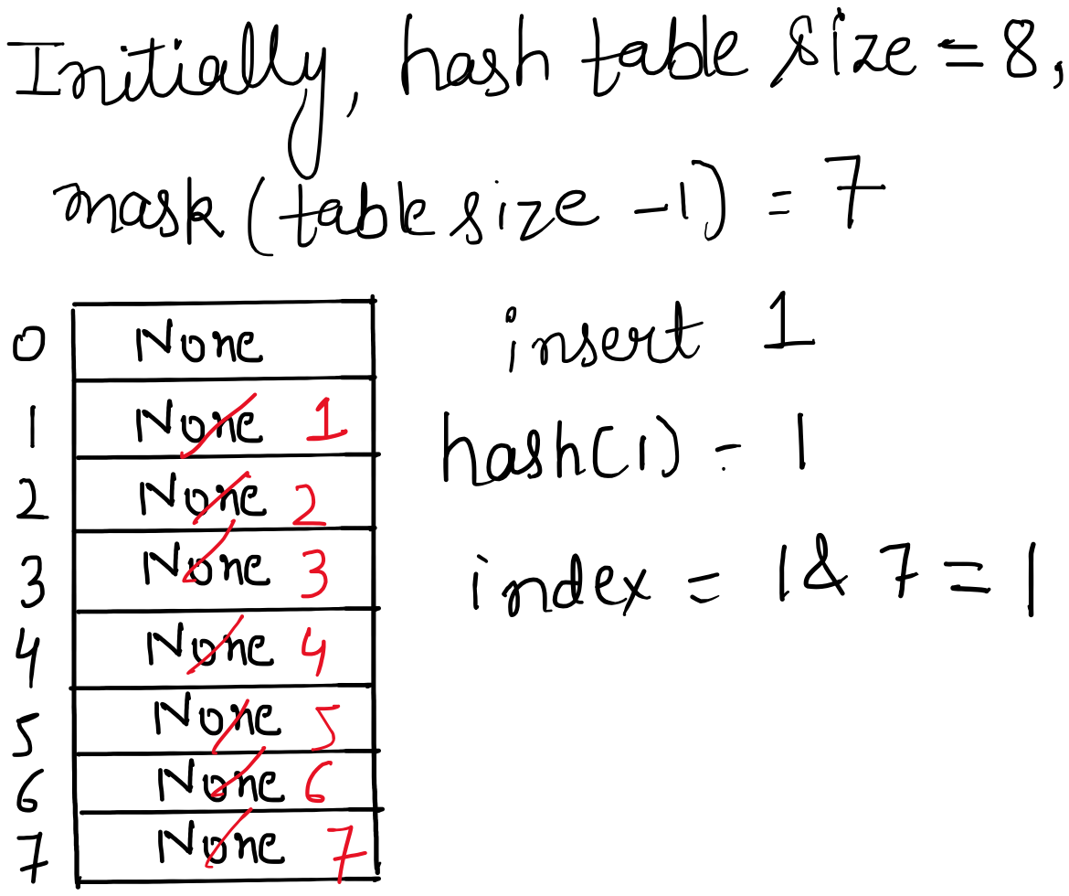
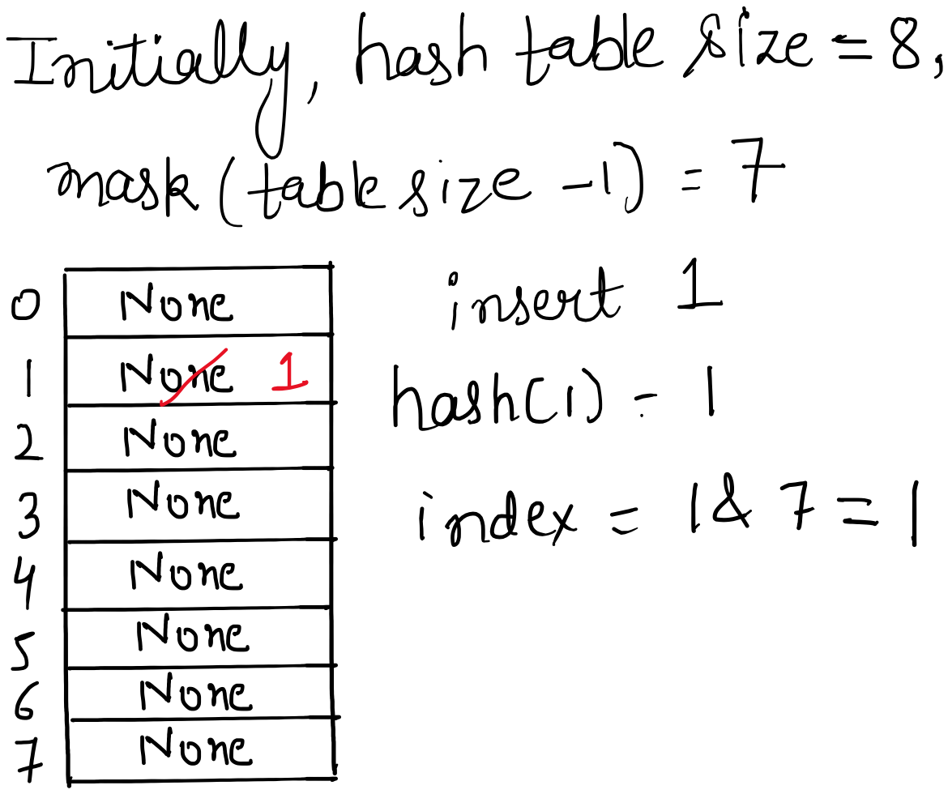

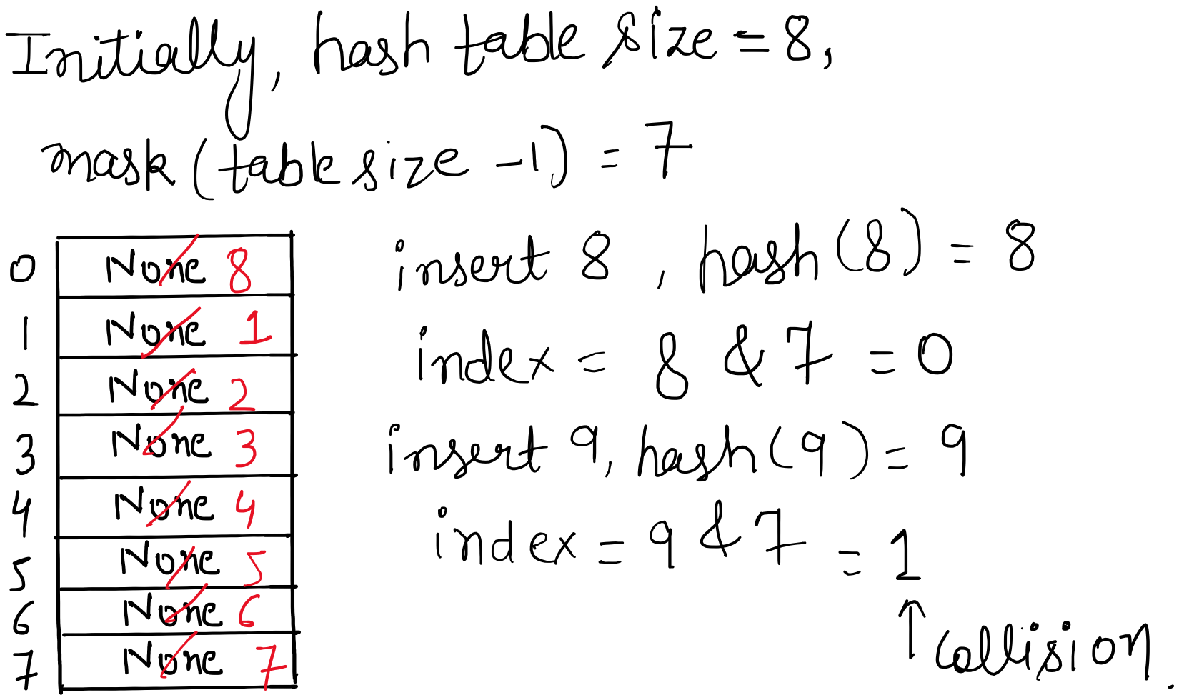

Here, in our program it will overwrite the data because we have not define how to resize the hash. So we need to modify the program i.e. use either mapping or define the hash function and equality function.

d = {}
for i in range(1, 11):
d[i] = i
print(" Inserted key = {i}, hash = { hash(i) } ")
print(d)

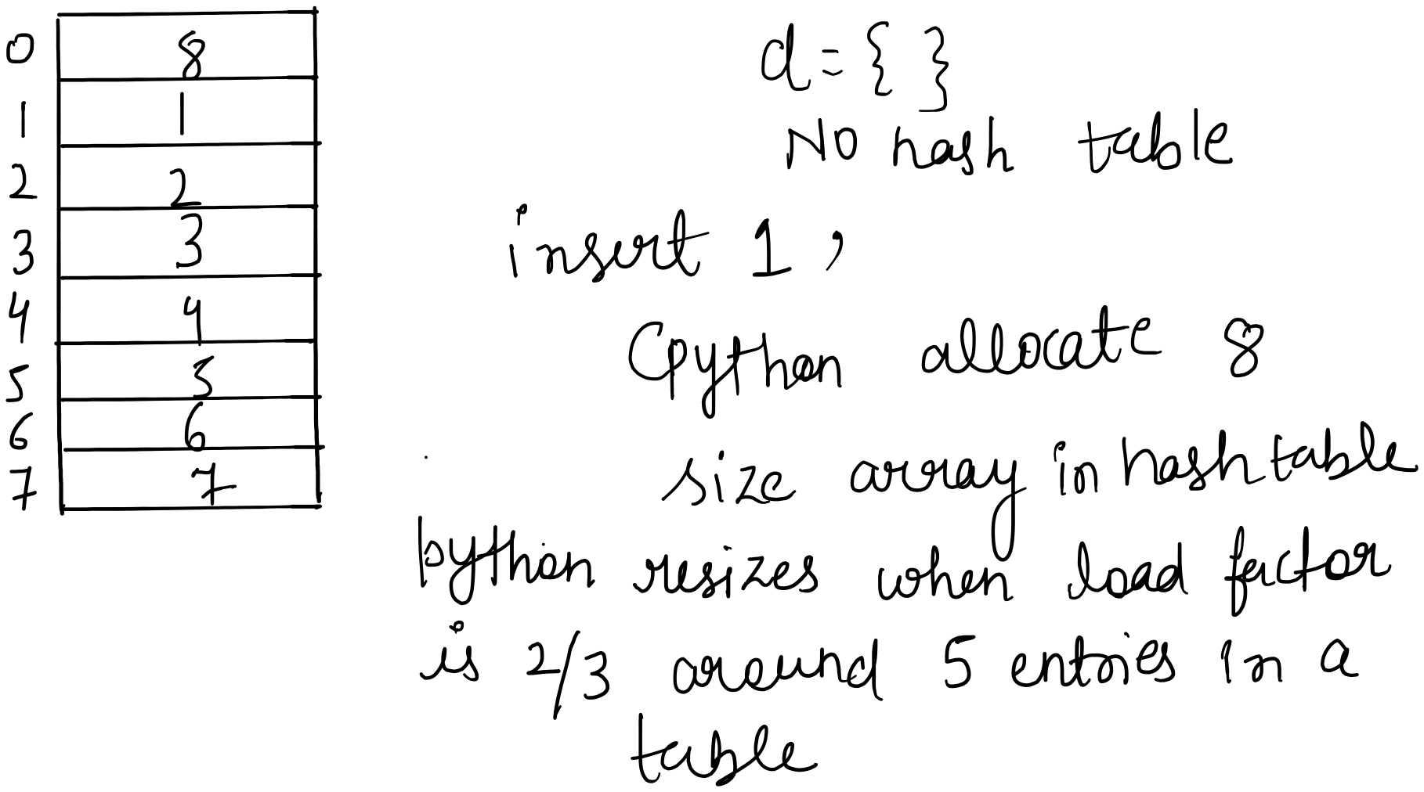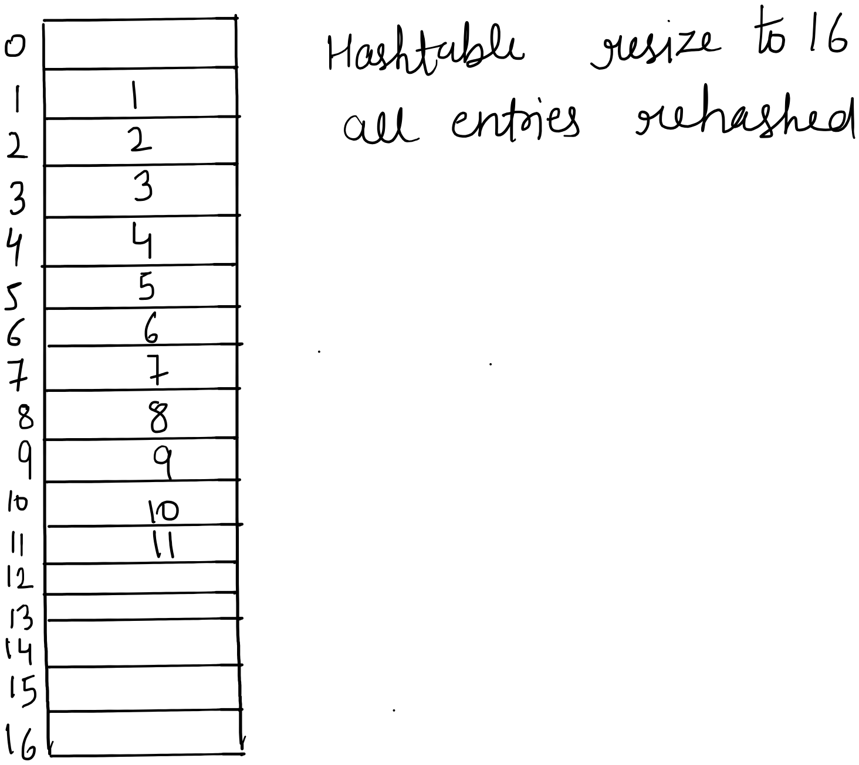

d = {}
i = 0
keys = ["a", "b", "c", "d", "e", "f", "g", "h", "i", "j"]
for k in keys:
d[k] = i
i = i + 1
print("Inserted key = ", i, " hash = ", hash(k))
print(d)
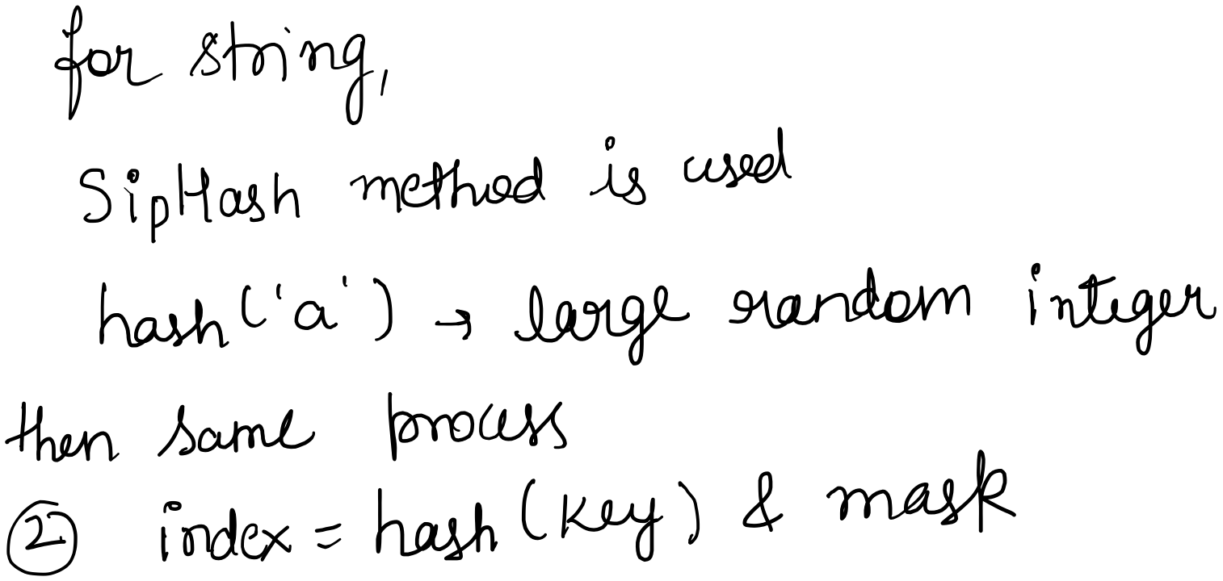

Output :
Inserted key = 1 hash = -8218280472543970493
Inserted key = 2 hash = -3827325906361336485
Inserted key = 3 hash = -4948323102665822432
Inserted key = 4 hash = 1971225784073597204
Inserted key = 5 hash = 3663403861707437436
Inserted key = 6 hash = 3829825252540006469
Inserted key = 7 hash = 3607616875020368874
Inserted key = 8 hash = 5449107731910632410
Inserted key = 9 hash = 2656605679432823097
Inserted key = 10 hash = -5029723645813760231
{'a': 0, 'b': 1, 'c': 2, 'd': 3, 'e': 4, 'f': 5, 'g': 6, 'h': 7, 'i': 8, 'j': 9}
—--------------------------------------
class Student:
def __init__(self, roll, name):
self.roll = roll
self.name = name
def __hash__(self):
return hash(self.roll)
def __eq__(self, other):
return isinstance(other, Student) and self.roll == other.roll
d = {}
students = [Student(1, "A"), Student(2, "B"), Student(3, "C"),Student(4, "D"), Student(9, "E")]
for s in students:
d[s] = s.name
print("Inserted key =", s.roll, "hash =", hash(s))

Output :
Inserted key = 1 hash = 1
Inserted key = 2 hash = 2
Inserted key = 3 hash = 3
Inserted key = 4 hash = 4
Inserted key = 9 hash = 9

https://docs.python.org/3/library/functions.html#hash https://docs.python.org/3/tutorial/datastructures.html#dictionaries

Feature | Java – HashMap | C++ – unordered_map | Python – dict
Hash table type | Array of buckets | Array of buckets | Array of slots
Hashing method | Open hashing (separate chaining) | Open hashing (separate chaining) | Closed hashing (open addressing)
Hash function | hashCode() | std::hash<Key> | __hash__()
Index calculation | (capacity − 1) & hash | hash % bucket_count | hash & (capacity − 1)
Capacity constraint | Power of 2 | Not necessarily power of 2 | Always power of 2
Collision resolution | Linked list | Linked list / node chain | Probing
High collision optimization | Red-Black Tree (Java 8+) | None | None
Probing used | No | No | Yes (perturbation probing)
Load factor (default) | 0.75 | 1.0 | ~0.66
Resize condition | size > capacity × loadFactor | size > buckets × max_load_factor | When load factor exceeds ~0.66
Order preservation | No | No | Yes (3.7+)
Worst-case lookup | O(log n) | O(n) | O(n)
Average lookup | O(1) | O(1) | O(1)

